Chapter 11

1. Create a central camera and a cube target and visualize it for different camera and cube poses.

Using the code:

cam = CentralCamera('focal', 0.015, 'pixel', 10e-6, ...

'resolution', [1280 1024], 'centre', [640 512], 'name', 'mycamera')

[X,Y,Z] = mkcube(0.2, 'T', transl([0, 0, 1]), 'edge');

cam.mesh(X, Y, Z)

and a cube is being displayed:

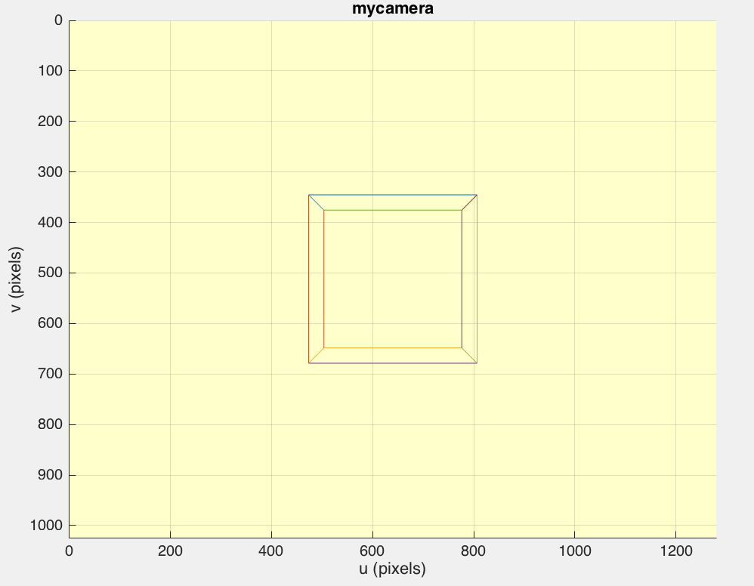

We visualize it for a different cube pose by rotating and moving the camera:

Tcam = transl(-1,0,0.5)*troty(1);

cam.mesh(X, Y, Z, 'Tcam', Tcam);

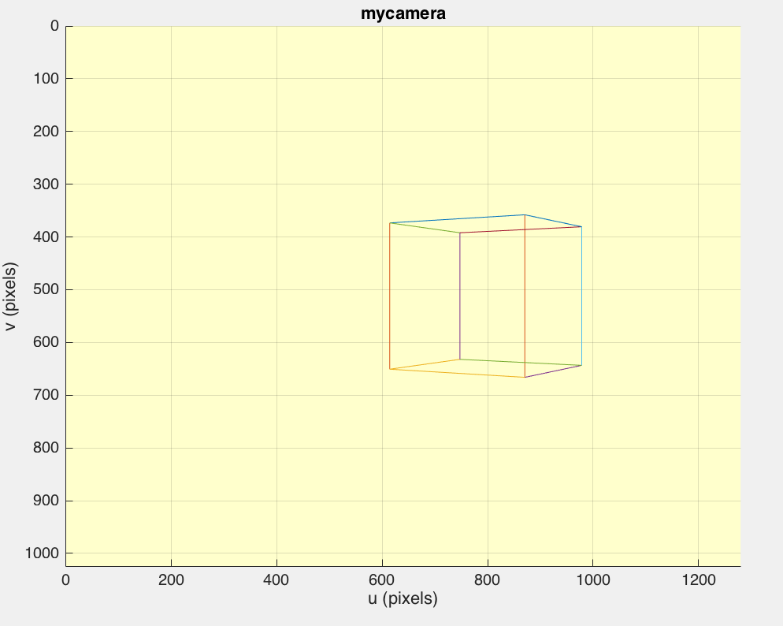

Now we change cameras parameters(pixels, focal length) in order to create a new camera and we visualize the cube for a different pose.

cam = CentralCamera('focal', 0.01, 'pixel', 10e-6, ...

'resolution', [1280 720], 'centre', [640 512], 'name', 'camera f=0.01 , 1280x720')

th=30*pi/180

Tcam = transl(cos(th),0,1+sin(th))*troty(-pi/2-th);

cam.mesh(X, Y, Z, 'Tcam', Tcam);

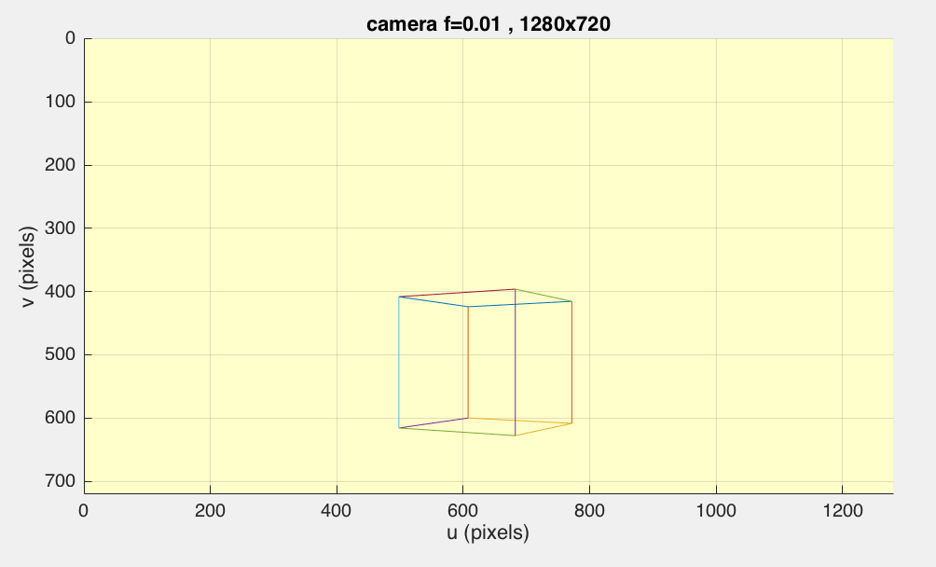

1. Write a script to fly the camera in an orbit around the cube, always facing toward the centre of the cube.

We create a script that rotates the camera along y axis in a circular orbit:

cam = CentralCamera('focal', 0.015, 'pixel', 10e-6, ...

'resolution', [1280 1024], 'centre', [640 512], 'name', 'mycamera')

[X,Y,Z] = mkcube(0.2, 'T', transl([0, 0, 1]), 'edge');

theta= [0:2*pi/180:2*pi]; %create an angle vector

for th=theta

Tcam = transl(cos(th),0,1+sin(th))*troty(-pi/2-th); %polar coo

cam.mesh( X, Y, Z, 'Tcam', Tcam);

drawnow

cam.clf

end

Some random fragments of its orbit

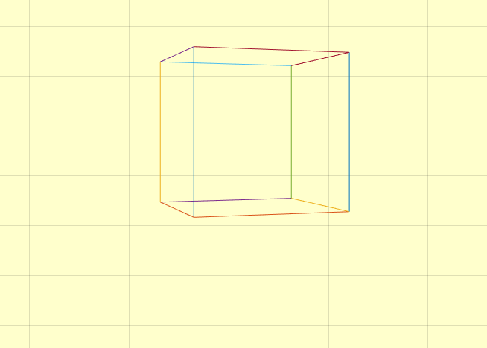

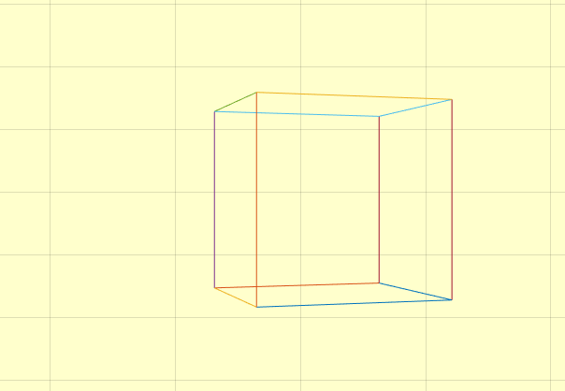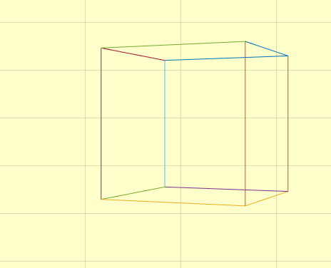

1. Write a script to fly the camera through the cube.

cam = CentralCamera('focal', 0.015, 'pixel', 10e-6, ...

'resolution', [1280 1024], 'centre', [640 512], 'name', 'mycamera')

[X,Y,Z] = mkcube(0.2, 'T', transl([0, 0, 1]), 'edge');

zita = [0:0.03:1.2]; % create a distance vector

Tcam = transl(0,0,0);

for z=zita

Tcam = transl(0, 0, z) %moving the camera closer to the center of %the cub on the z-axis

cam.mesh( X, Y, Z, 'Tcam', Tcam )

drawnow

cam.clf

end

Some random fragments:

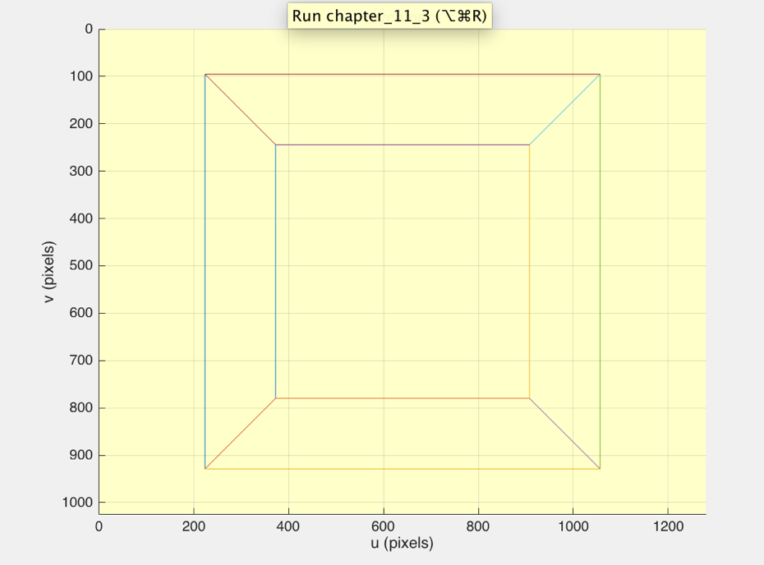

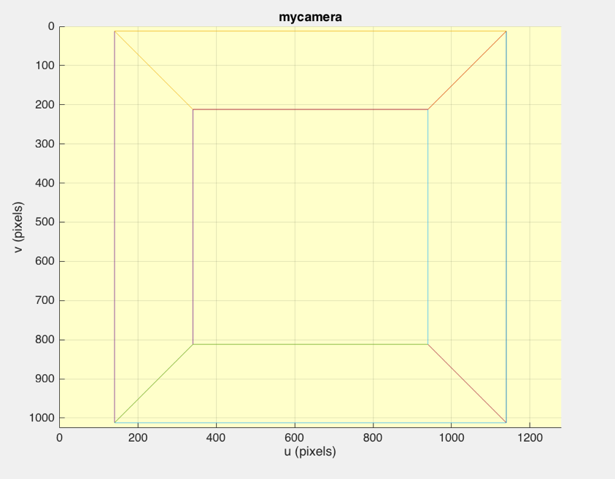

1. Create a central camera with lens distortion and which is viewing a 10 × 10 planar  grid of points. Vary the distortion parameters and see the effect this has on the  shape of the projected grid. Create pincushion and barrel distortion.

At first, we create the grid

cam = CentralCamera('focal', 0.015, 'pixel', 10e-6, ...

'resolution', [1280 1024], 'centre', [512 512], 'name', 'mycamera') %without distortion

P = mkgrid(10, 0.5, 'T', transl(0.1, 0, 1.0));

cam.plot(P)

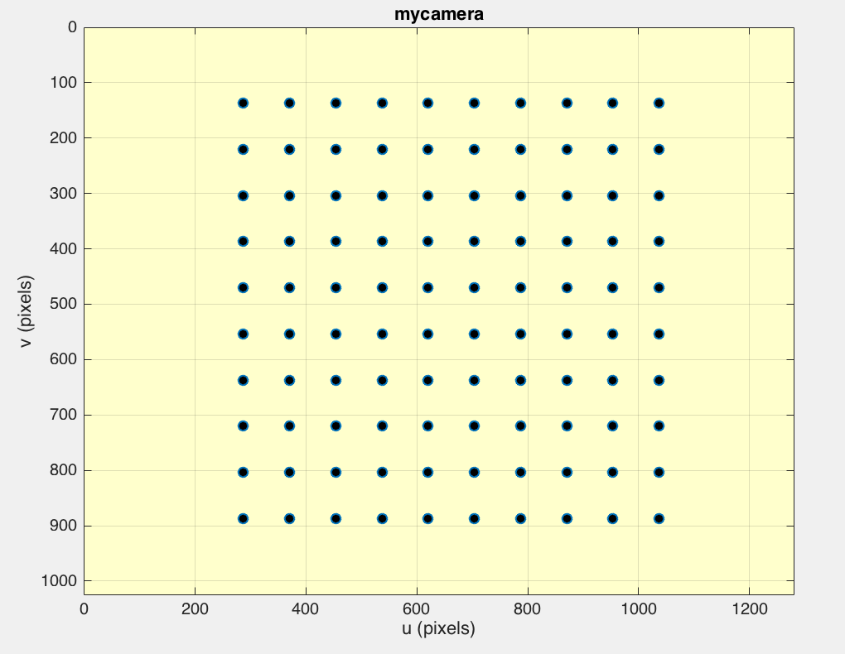

%% with random distortion

The distortion model is parameterized by (*k*1, *k*2, *k*3, *p*1, *p*2).

Distortion can be modelled by the CentralCamera class using the 'distortion' option.

For some random parameters of the distortion model [0 -0.5 0.5 0 1] :

cam_dist = CentralCamera('focal', 0.015, 'pixel', 10e-6, ...

'resolution', [1280 1024], 'centre', [512 512], ...

'distortion', [0 -0.5 0.5 0 1] ) %me distortion

cam_dist.plot(P)

creates an extremely deformed view of the grid:

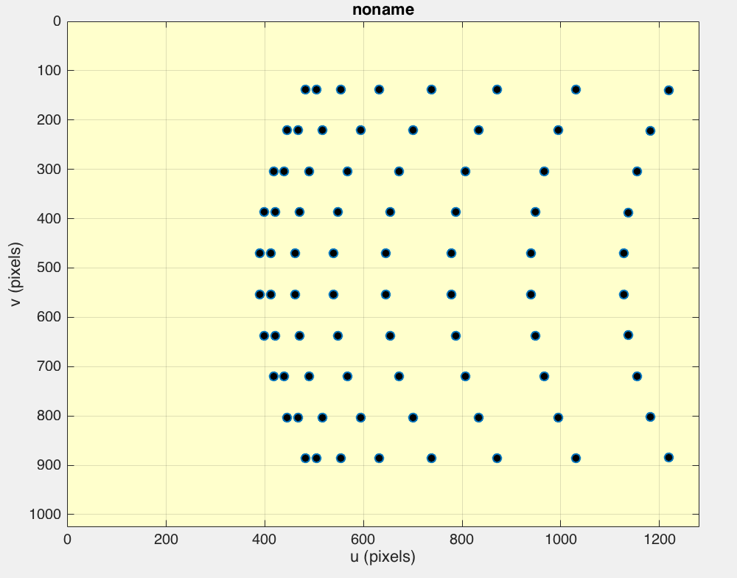

%% Pincushion distortion

In pincushion distortion, image magnification increases with the distance from the [optical axis](https://en.wikipedia.org/wiki/Optical_axis). The visible effect is that lines that do not go through the centre of the image are bowed inwards, towards the centre of the image, like a [pincushion](https://en.wikipedia.org/wiki/Pincushion).

In order to create the Pincushion distortion, we increase the first 3 parameters of the distortion model:

cam_pin = CentralCamera('focal', 0.015, 'pixel', 10e-6, ...

'resolution', [1280 1024], 'centre', [512 512], ...

'distortion', [0.5 0.5 0.5 0 0] ) %me distortion

cam_pin.plot(P)

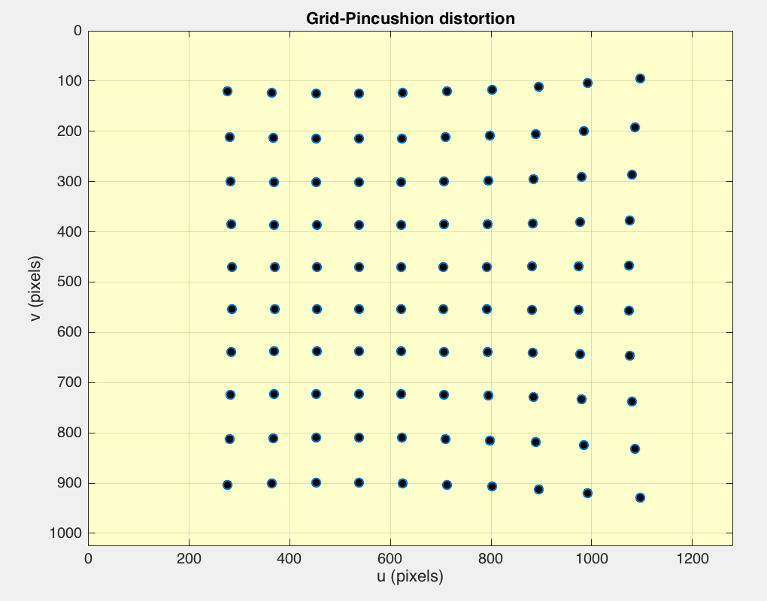

**Barrel distortion**

In barrel distortion, image [magnification](https://en.wikipedia.org/wiki/Magnification) decreases with distance from the [optical axis](https://en.wikipedia.org/wiki/Optical_axis). The apparent effect is that of an image which has been mapped around a [sphere](https://en.wikipedia.org/wiki/Sphere) (or [barrel](https://en.wikipedia.org/wiki/Barrel)).

cam_bar = CentralCamera('focal', 0.015, 'pixel', 10e-6, ...

'resolution', [1280 1024], 'centre', [512 512], ...

'distortion', [-0.8 -0.8 -0.8 0 0] ) %me distortion

cam_bar.plot(P)

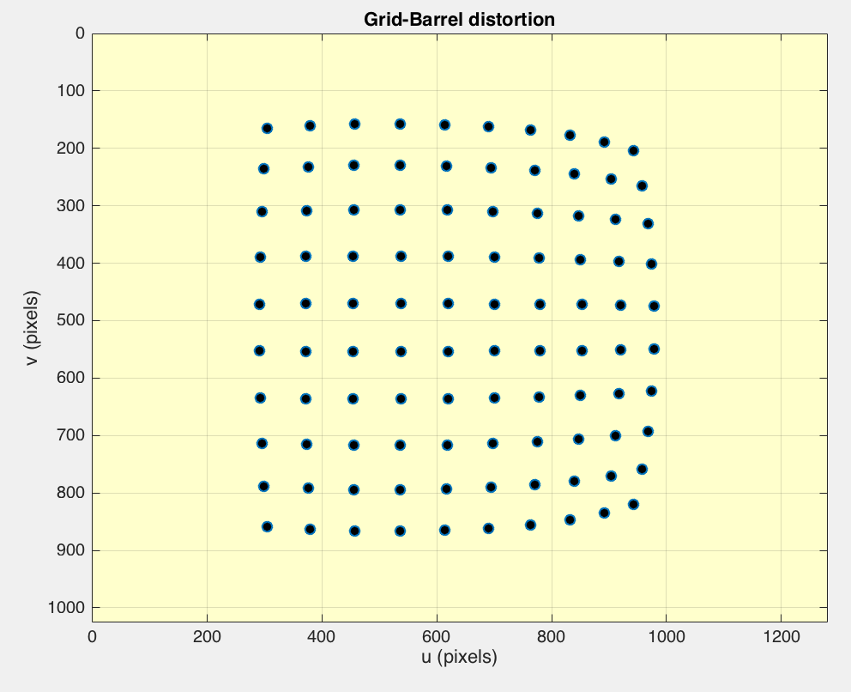

1. Repeat the homogeneous camera calibration exercise of Sect.11.2.1 and investigate the effect of the number of calibration points, noise and camera distortion on the calibration residual and estimated target pose.

P = mkcube(0.2);

T_unknown = transl(0.1, 0.2, 1.5) * rpy2tr(0.1, 0.2, 0.3);

cam = CentralCamera('focal', 0.015, ...

'pixel', 10e-6, 'resolution', [1280 1024], 'centre', [512 512], ...

'noise', 0.05);

p = cam.project(P, 'Tobj', T_unknown);

C = camcald(P, p)

Using just the object model P and the observed image features p we estimate the camera matrix

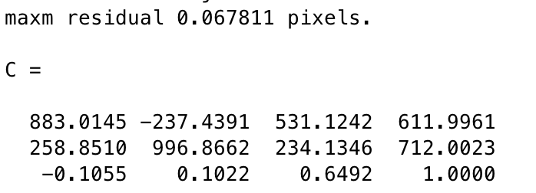

Small error (maximum residual less than 0.1 pixel)

Distortion acceptably low.

For a value of Gaussian noise equal to 1.5 we estimate again the camera matrix.

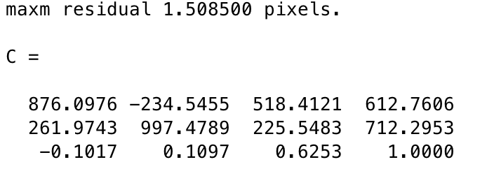

As we notice the maximum residual in this case is 1.5 pixels. That means the error be- tween the projection of a world point using the camera matrix ***C*** and the actual image plane location is much bigger now.

Now camera distortion equal to [1,1,1,0,0.2] is being added.

We estimate again the camera matrix:

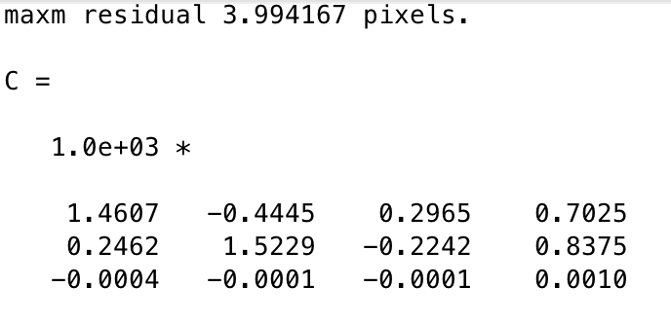

The distortion definitely introduces errors into the camera matrix elements and now the maximum residual has a value of 4 pixels.

1. Determine the solid angle for a rectagular pyramidal field of view that subtends angles θ*h* and θ*v*.

The field of view of a lens is an open rectangular pyramid that subtends angles θh and θv in the horizontal and vertical planes respectively.

$dΩ=sinθ θv$ θ*h*

$$dΩ=\iint_{S}{sinθ θv θh}$$

Thus the whole solid angle of a rectangular pyramid, with high h and side length of each side a and b, is

$$Ω=4arcsin\frac{ab}{\sqrt{16d^{4}+4a^{2}d^{2}+4b^{2}d^{2}}}$$

1. Do example 1 from Bouguet’s Camera Calibration Toolbox.

The calibration tool is launched by the command calib_gui

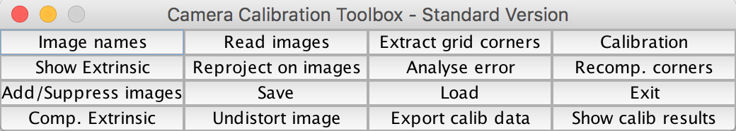

We click on the **Image names** button in order to load all the images that we are going to extract grid corners from :

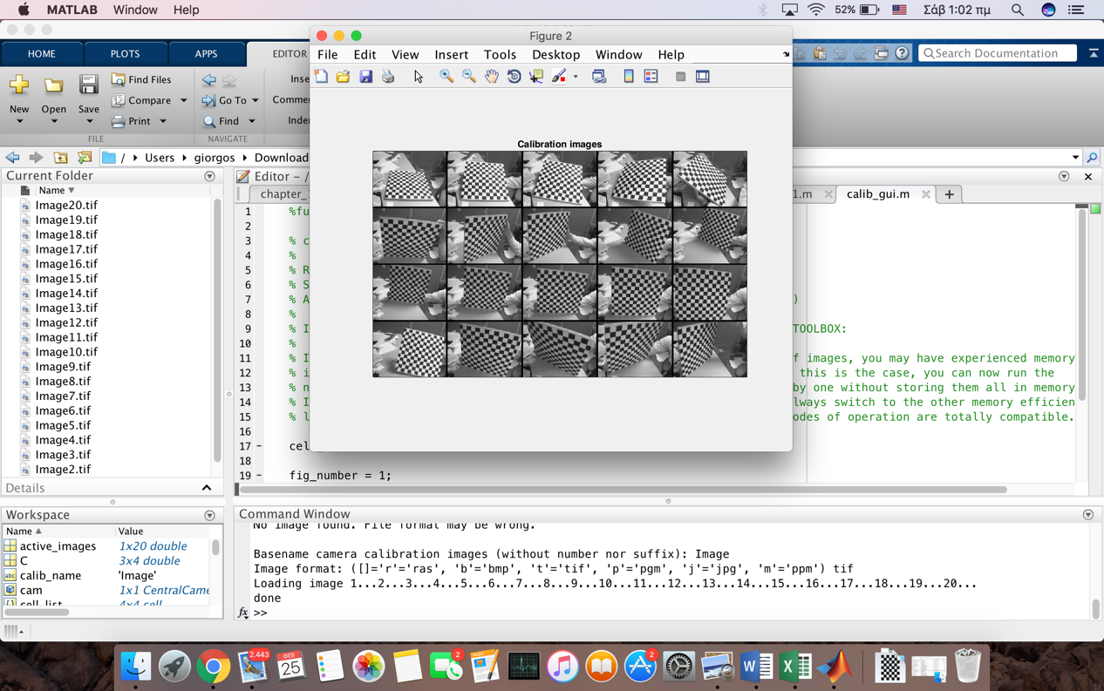

We now click on the **Extract grid corners** button in the **Camera calibration tool** window. We manually click on the edges of each and every photo so as to extract the grid corners. After the first photo we enter the size of each square along the X and Y direction which is 30mm.

Some examples of the extracted grid corners are shown below.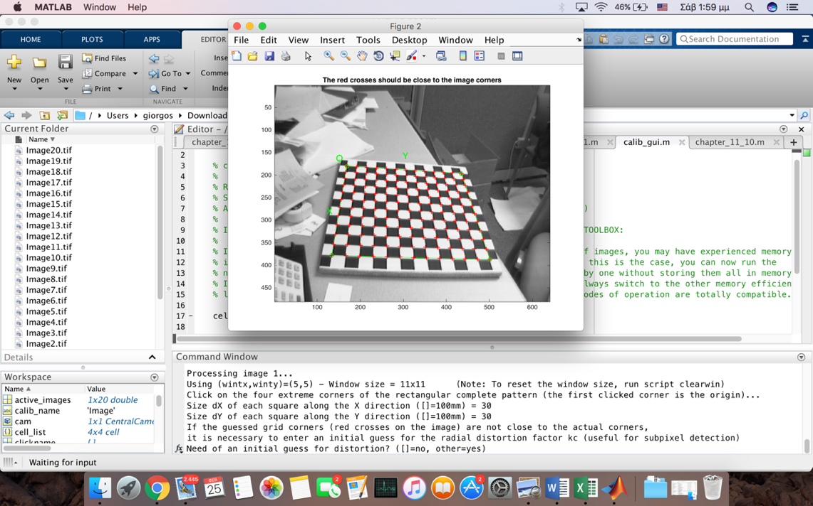

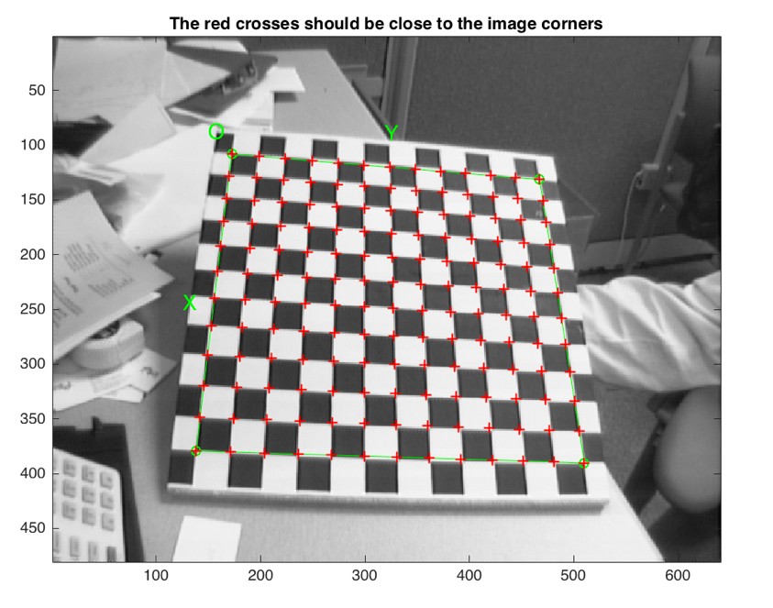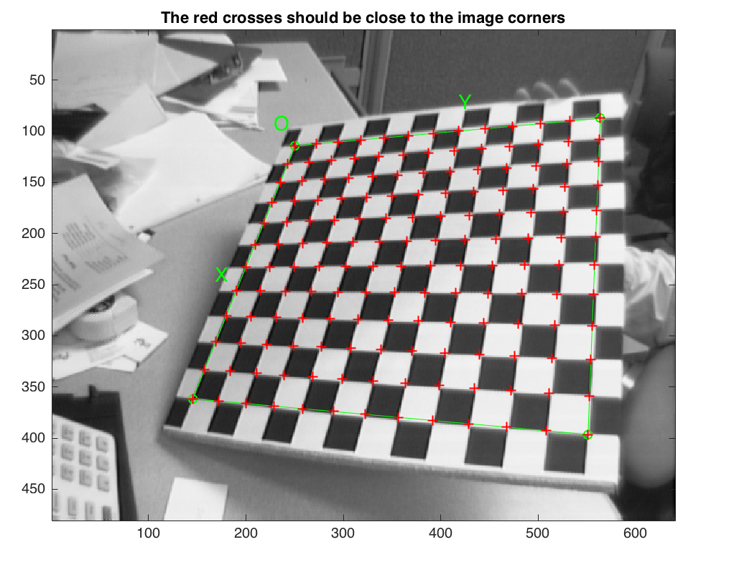

At some point at the 15th photo we observe that some of the predicted corners within the grid are far enough from the real grid corners to result into wrong extractions. The cause is image distortion. In order to help the system make a better guess of the corner locations, we input a guess for the first order lens distortion coefficient **kc**. That value for kc is -0.3

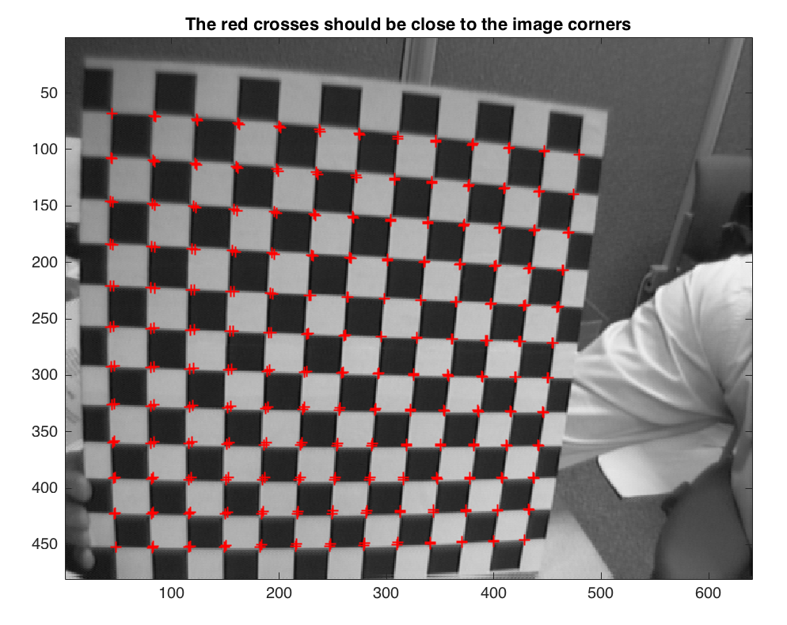

After corner extraction, we click on the button **Calibration** of the **Camera calibration tool** to run the main camera calibration procedure.

Calibration parameters after initialization:

Focal Length: fc = [ 670.66618 670.66618 ]

Principal point: cc = [ 319.50000 239.50000 ]

Skew: alpha_c = [ 0.00000 ] => angle of pixel = 90.00000 degrees

Distortion: kc = [ 0.00000 0.00000 0.00000 0.00000 0.00000 ]

Calibration results after optimization (with uncertainties):

Focal Length: fc = [ 661.66942 662.82797 ] +/- [ 1.17896 1.26549 ]

Principal point: cc = [ 306.09554 240.78980 ] +/- [ 2.38409 2.17450 ]

Skew: alpha_c = [ 0.00000 ] +/- [ 0.00000 ] => angle of pixel axes = 90.00000 +/- 0.00000 degrees

Distortion: kc = [ -0.26425 0.22644 0.00020 0.00023 0.00000 ] +/- [ 0.00933 0.03826 0.00052 0.00053 0.00000 ]

Pixel error: err = [ 0.45326 0.38907 ]

We now click on **Reproject on images** to show the reprojections of the grids onto the original images. These projections are computed based on the current intrinsic and extrinsic parameters.

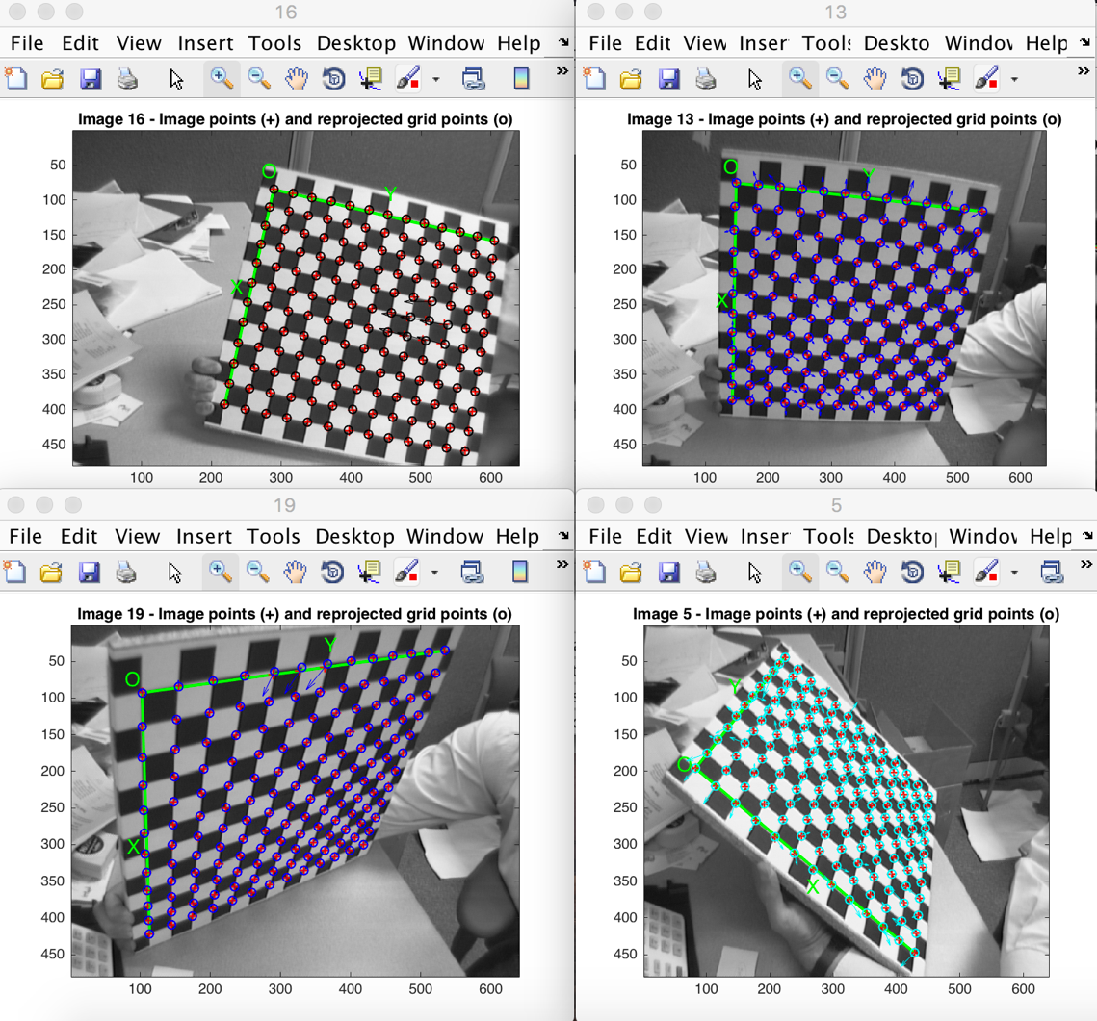

The reprojection error is also shown in the form of color-coded crosses:

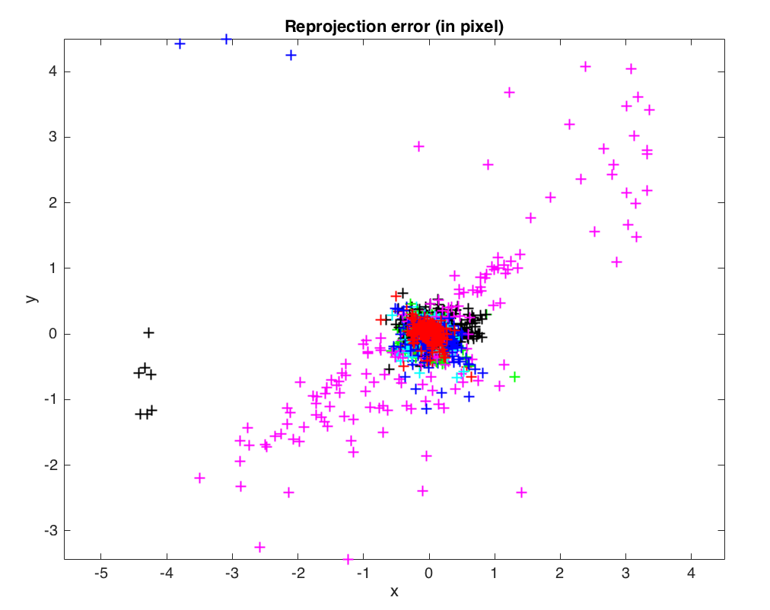

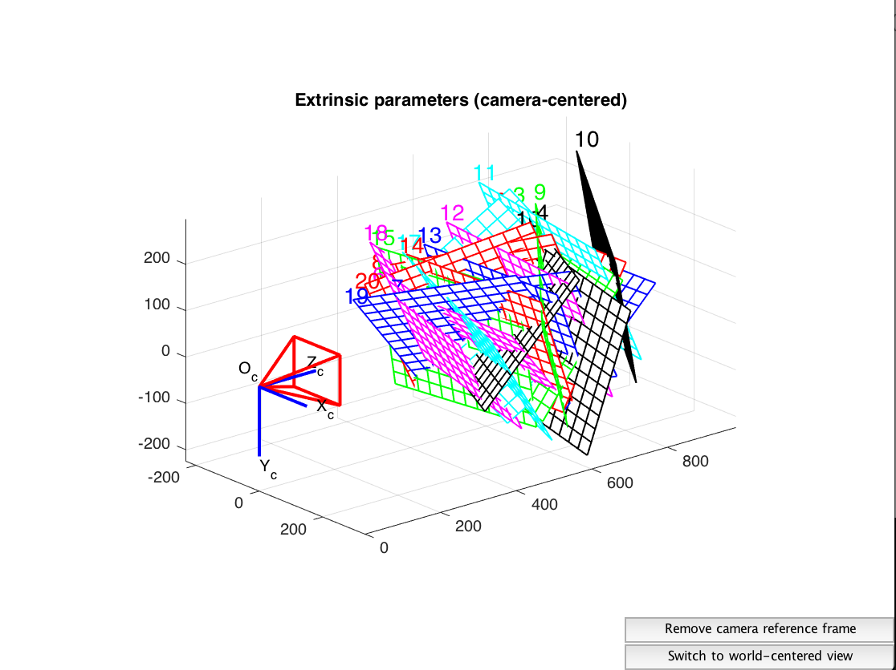

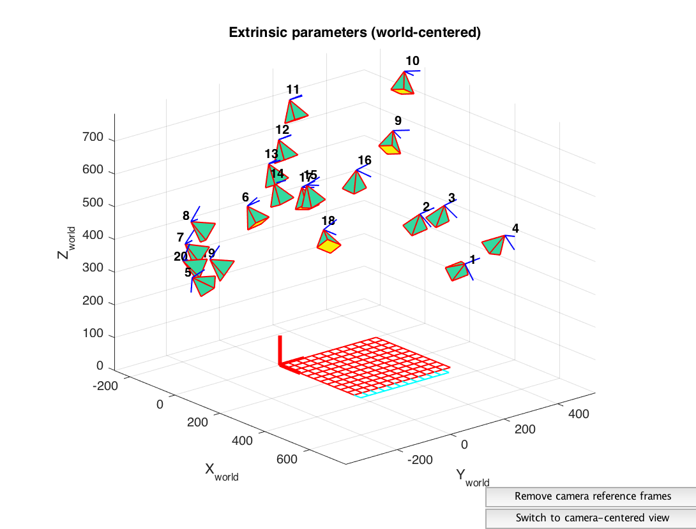

Looking back at the error plot, we notice that the reprojection error is very large across a large number of figures. The reason for that is that we have not done a very careful job at extracting the corners on some highly distorted images. Nevertheless, we can correct for that now by recomputing the image corners on all images automatically. We press on the **Recomp. corners** button in the main **Camera calibration tool** and run another calibration optimization by clicking on **Calibration**:

Calibration results after optimization (with uncertainties):

Focal Length: fc = [ 657.39535 657.76309 ] +/- [ 0.34691 0.37111 ]

Principal point: cc = [ 302.98368 242.61630 ] +/- [ 0.70546 0.64553 ]

Skew: alpha_c = [ 0.00000 ] +/- [ 0.00000 ] => angle of pixel axes = 90.00000 +/- 0.00000 degrees

Distortion: kc = [ -0.25584 0.12758 -0.00021 0.00003 0.00000 ] +/- [ 0.00271 0.01076 0.00015 0.00014 0.00000 ]

Pixel error: err = [ 0.12668 0.12604 ]

The new images look like:

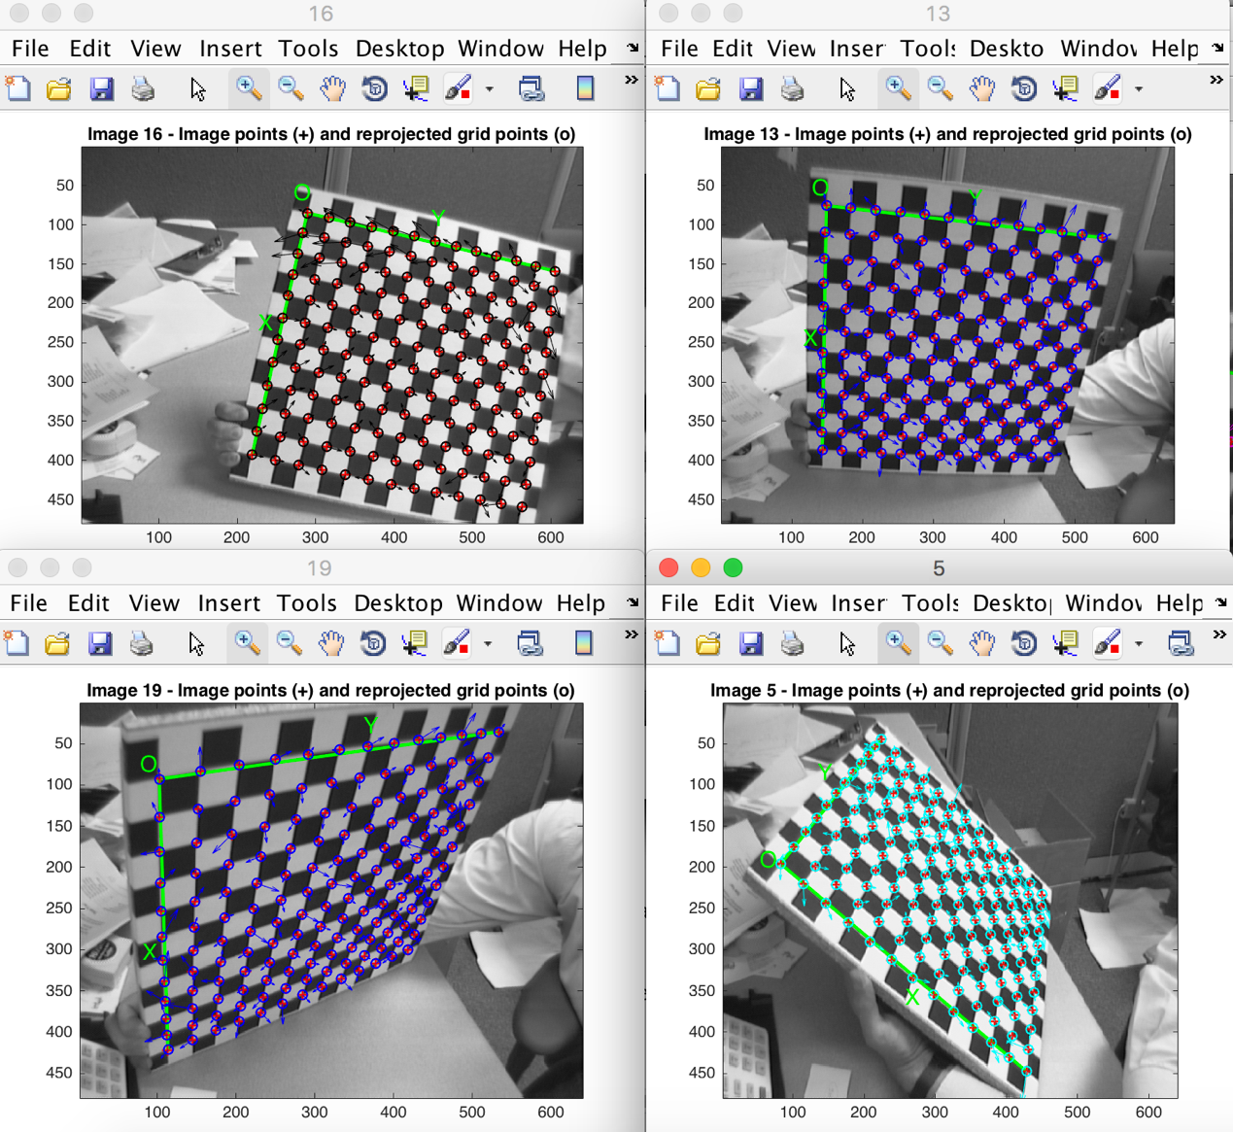

We Click on **Analyse error** to view the new reprojection error:

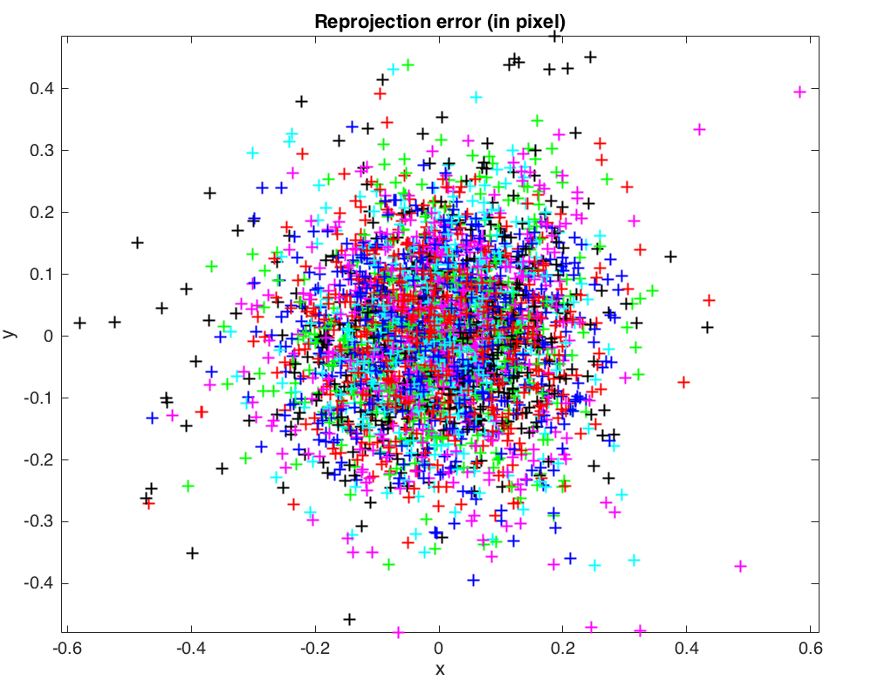

The the error is much smaller than before

At last we save the results by clicking once again on **Save** to save the calibration results in the matlab file **Calib_Results.mat**

1. Calibrate the camera on your computer.

We repeat the same procedure as before in order to calibrate the camera of an iphone se in our computer.

We take 17 from the iphone and we load them throught calibration gui.

The real size of each square along dy and dx is 10mm

Some examples of the grid corner extraction are shown below.

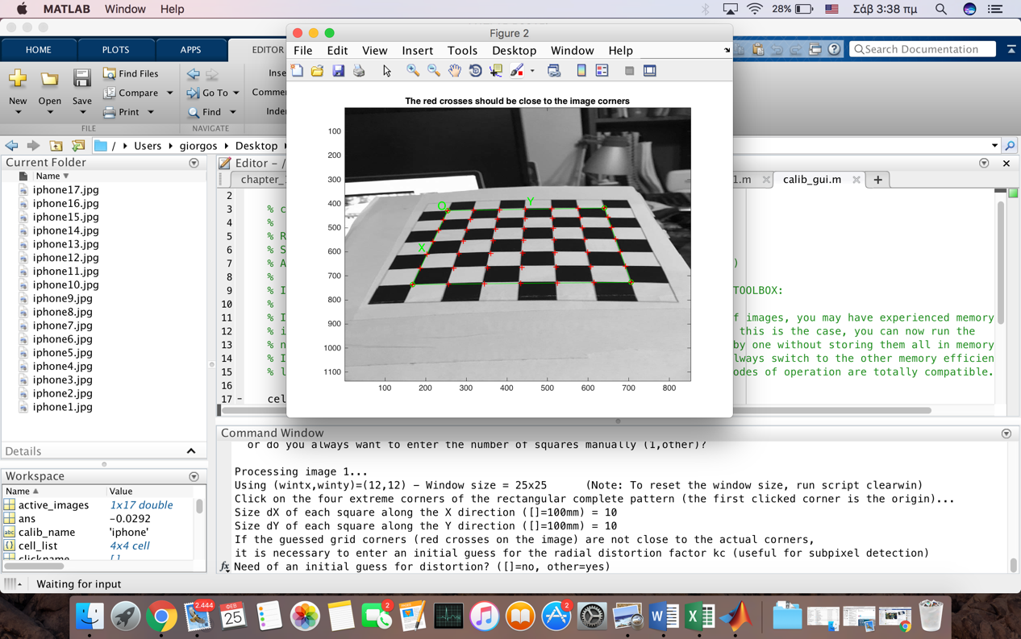

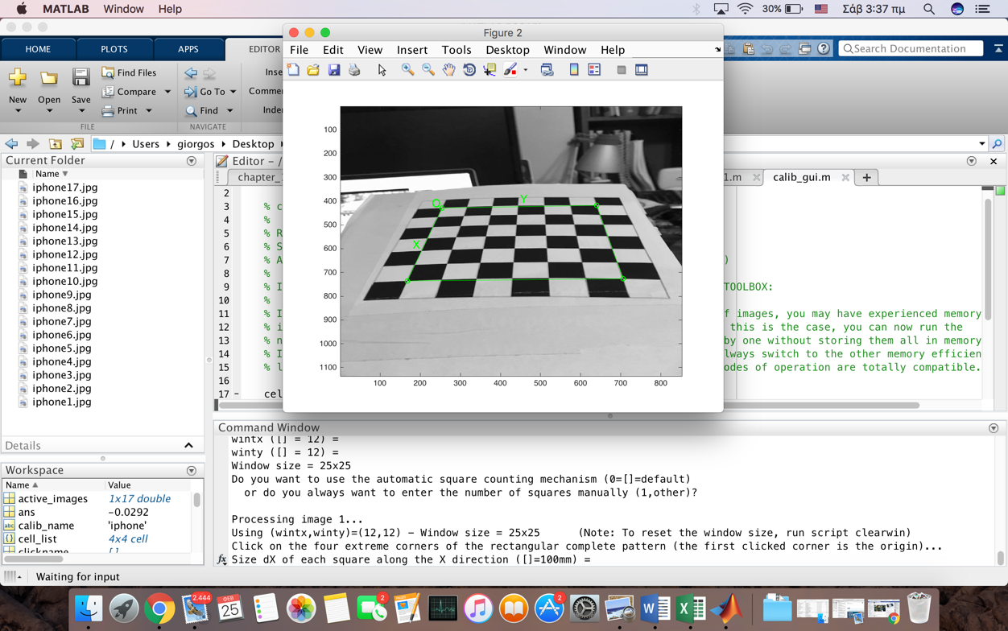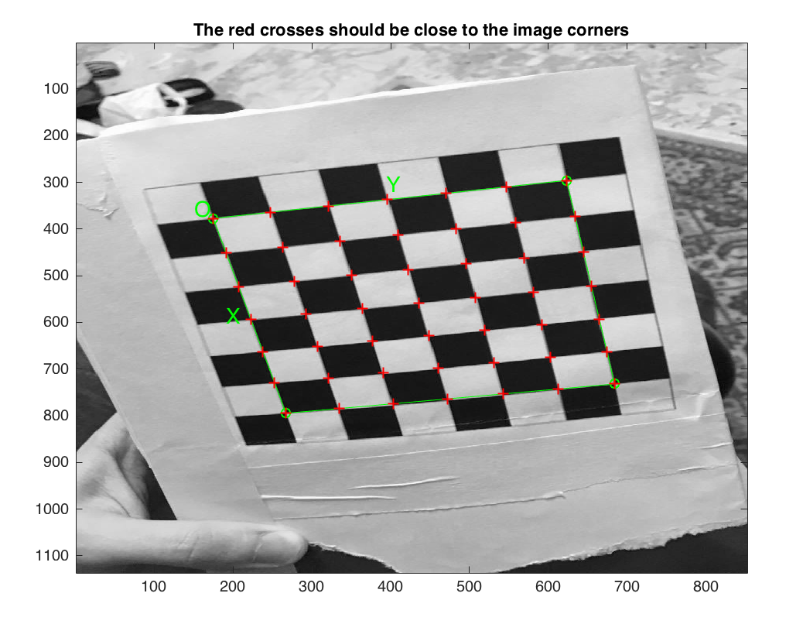

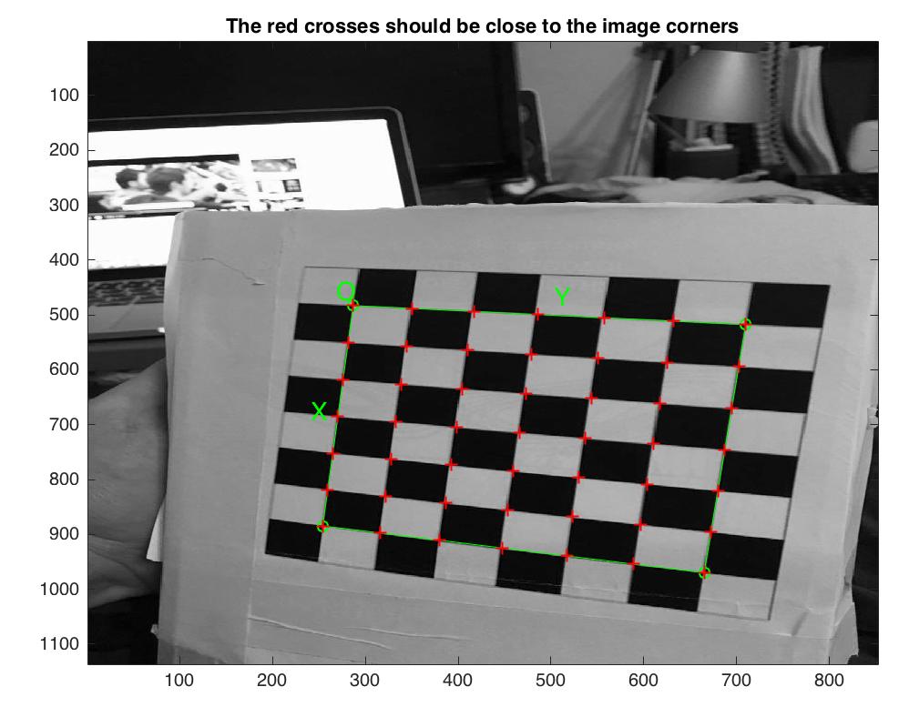

Calibration parameters after initialization:

Focal Length: fc = [ 985.45932 985.45932 ]

Principal point: cc = [ 425.50000 567.50000 ]

Skew: alpha_c = [ 0.00000 ] => angle of pixel = 90.00000 degrees

Distortion: kc = [ 0.00000 0.00000 0.00000 0.00000 0.00000 ]

Calibration results after optimization (with uncertainties):

Focal Length: fc = [ 983.09916 984.50554 ] +/- [ 8.14509 8.20184 ]

Principal point: cc = [ 416.37967 584.15999 ] +/- [ 10.96669 10.58868 ]

Skew: alpha_c = [ 0.00000 ] +/- [ 0.00000 ] => angle of pixel axes = 90.00000 +/- 0.00000 degrees

Distortion: kc = [ -0.01573 0.13792 0.00715 -0.00433 0.00000 ] +/- [ 0.04202 0.19829 0.00422 0.00411 0.00000 ]

Pixel error: err = [ 0.86206 1.15862 ]

We click on **Reproject on images** to reproject the grids onto the original calibration images.

Some of the new images look like:

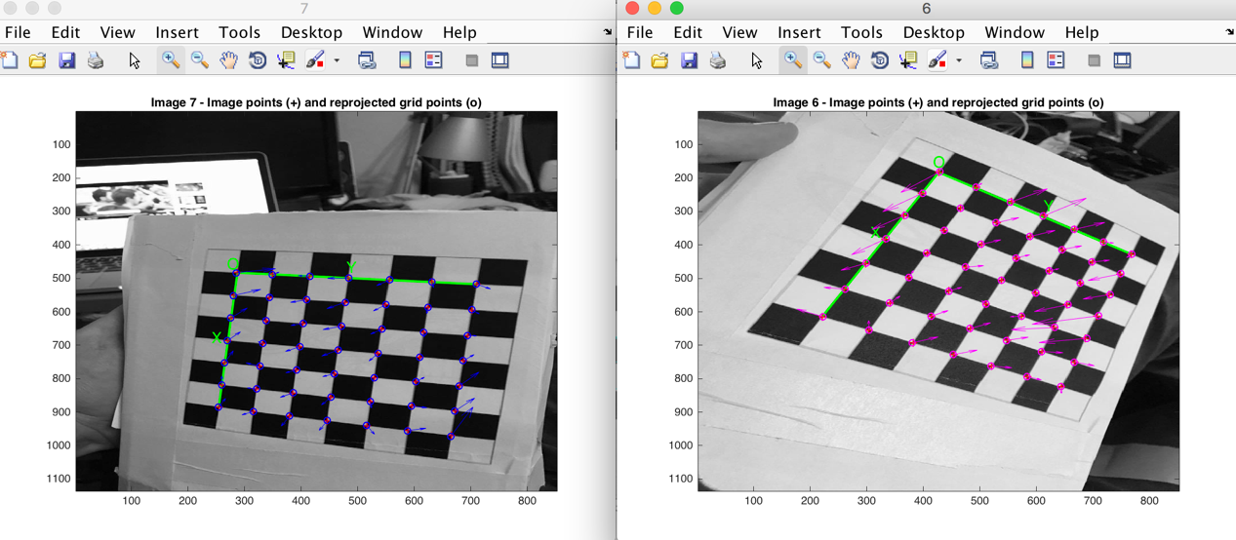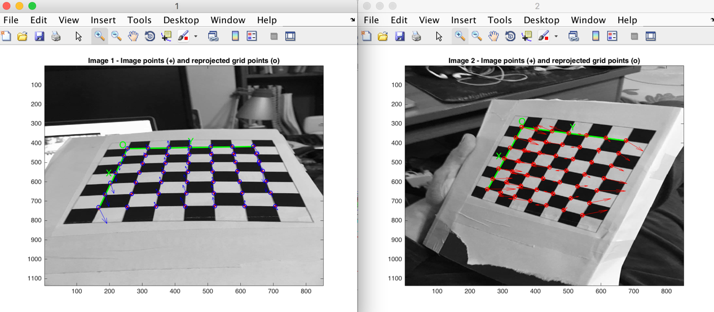 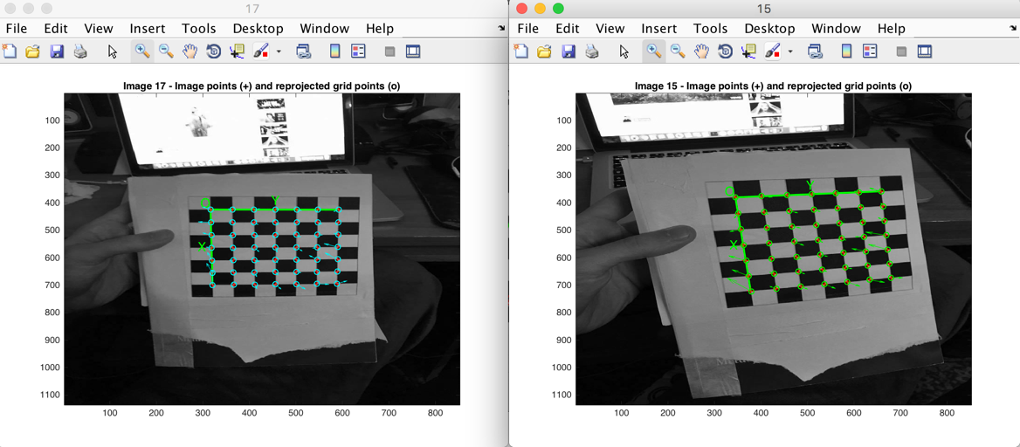

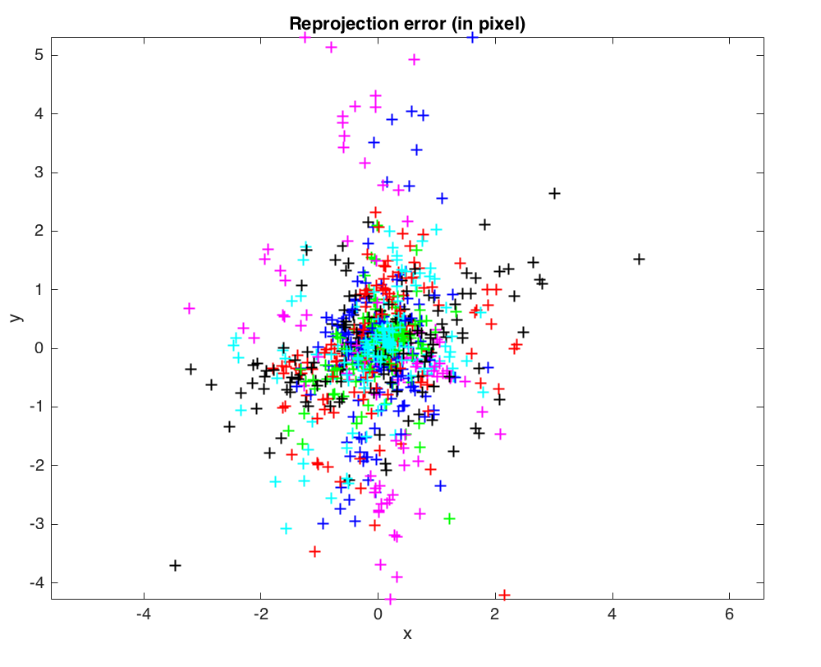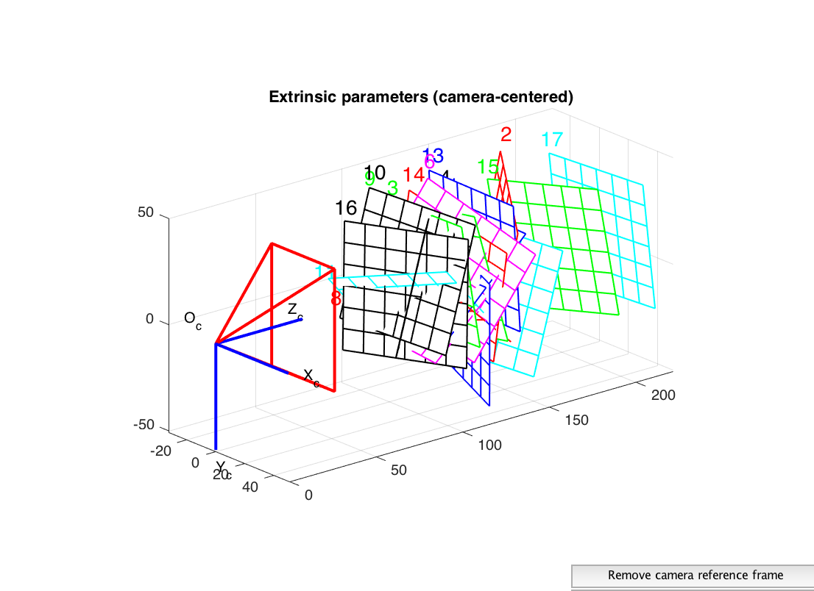

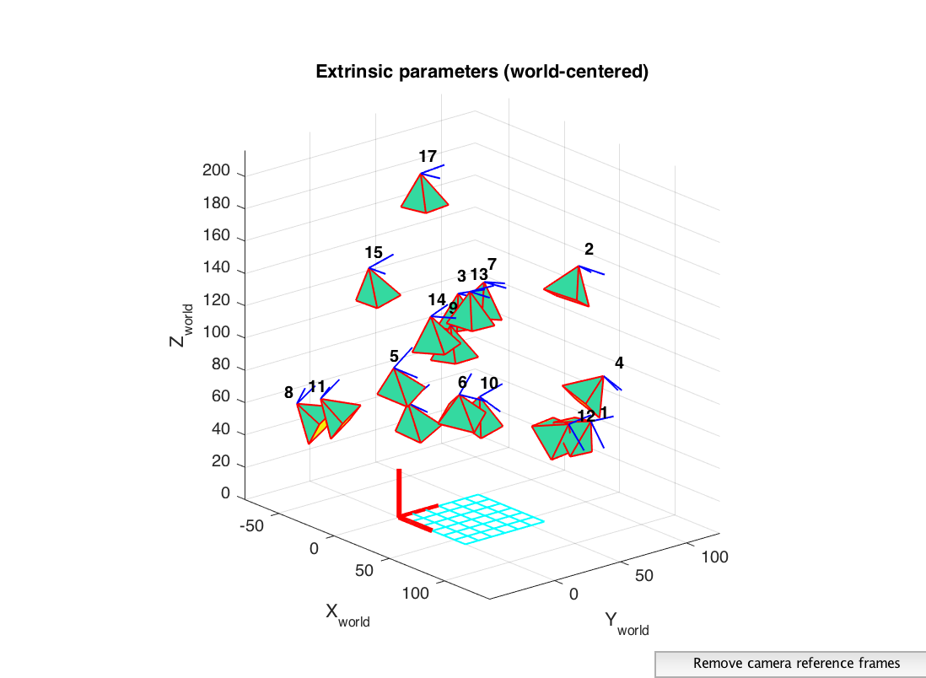

1. For the camera calibration matrix decomposition example(Sect.11.2.2) determine the roll-pitch-yaw orientation error between the true and estimated camera pose.

P = mkcube(0.2);

T_unknown = transl(0.1, 0.2, 1.5) * rpy2tr(0.1, 0.2, 0.3);

cam = CentralCamera('focal', 0.015, ...

'pixel', 10e-6, 'resolution', [1280 1024], 'centre', [512 512], ...

'noise', 0.05);

p = cam.project(P, 'Tobj', T_unknown);

C = camcald(P, p);

est = invcamcal(C);

Error of the true pose

est.f/est.rho(1)

true_error = -1.5048e+03

Error of the estimated pose

cam.f/cam.rho(2)

estimated_error = 1.5000e+03

In order to determine the orientation error we substract the error of the true pose from the error of the estimated pose.

orientation_error=est.f/est.rho(1)-cam.f/cam.rho(2)

orientation_error = -3.0048e+03

10.Pose estimation (Sect. 11.2.3)

a)  Repeat the pose estimation exercise for different object poses (closer, further away).

The pose estimation problem is to determine the pose *C*ξ*T* of a target’s coordinate frame {*T*} with respect to the camera.

We will create a calibrated camera with known parameters

cam = CentralCamera('focal', 0.015, 'pixel', 10e-6, ...

'resolution', [1280 1024], 'centre', [640 512]);

The object whose pose we wish to determine is a cube with side lengths of 0.2 m and the coordinates of the markers with respect to {*T*} are

P = mkcube(0.2);

The object is at some arbitrary but unknown pose *C*ξ*T* pose with respect to the camera

T_unknown = transl(0,0,2)*trotx(0.1)*troty(0.2) % change z of transl

T_unknown =

0.9801 0 0.1987 0

0.0198 0.9950 -0.0978 0

-0.1977 0.0998 0.9752 2.0000

0 0 0 1.0000

The image plane coordinates of the object’s points at its unknown pose are

p = cam.project(P, 'Tobj', T_unknown);

Now using just the object model P, the observed image features p and the calibrated camera cam we estimate the relative pose *C*ξ*T* of the object

T_est = cam.estpose(P, p)

T_est =

0.9801 0.0000 0.1987 -0.0000

0.0198 0.9950 -0.0978 0.0000

-0.1977 0.0998 0.9752 2.0000

0 0 0 1.0000

As we notice the estimated pose is the same (to four decimal places) as the unknown pose of the object.

* We now repeat the same procedure but we change the object pose. By increasing the distance on z-axis we place the camera further away from the cube

T_unknown = transl(0,0,5)*trotx(0.1)*troty(0.2)

T_unknown =

0.9801 0 0.1987 0

0.0198 0.9950 -0.0978 0

-0.1977 0.0998 0.9752 5.0000

0 0 0 1.0000

we estimate the relative pose *C*ξ*T* of the object

T_est =

0.9801 0.0000 0.1987 -0.0000

0.0198 0.9950 -0.0978 -0.0000

-0.1977 0.0998 0.9752 5.0000

0 0 0 1.0000

* By decreasing the distance on z-axis we place the camera further closer to the cube

T_unknown = transl(0,0,0.3)*trotx(0.1)*troty(0.2)

T_unknown =

0.9801 0 0.1987 0

0.0198 0.9950 -0.0978 0

-0.1977 0.0998 0.9752 0.3000

0 0 0 1.0000

T_est =

0.9801 0.0000 0.1987 0.0000

0.0198 0.9950 -0.0978 0.0000

-0.1977 0.0998 0.9752 0.3000

0 0 0 1.0000

As we notice in both object poses the unknown pose is similar to the estimated one.